Hello everyone!
I am excited to share our third issue of our science journal, Plasmodesmata, with you. For those of you that are new, plasmodesmata (singular: plasmodesma) are microscopic tunnels that form between two neighboring plant cells that allow the exchange of information and other materials. They are very tiny, usually less than 100 nm wide in most plants, which is about a thousand times thinner than a human hair. However, as you can see in the picture below, most plant cells have many of these channels, allowing the exchange of many tiny messages at once.
PLASMODESMATA
Channels to exchange information between cells
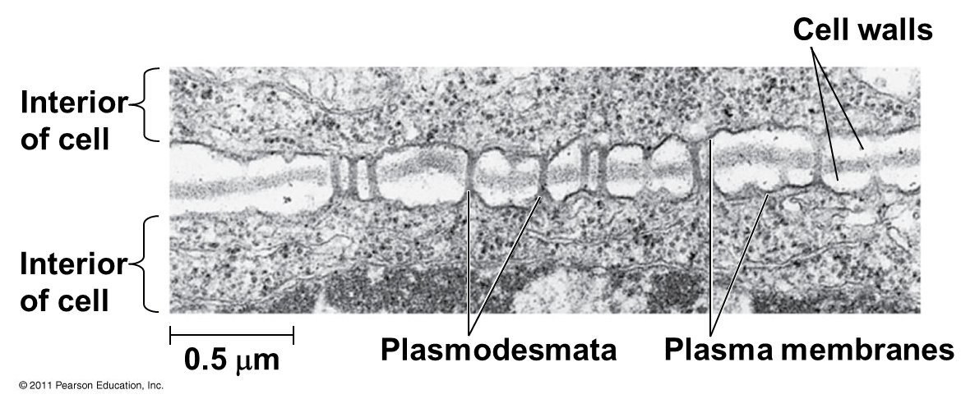
My hope is that this journal will provide a portal for us scientists to share information with you from our cells (or labs, as we like to call them) to yours, much like the plasmodesmata of plant cells.
Prisoner Express 127 Anabel Taylor Hall Ithaca, NY 14850
On behalf of the authors of the second issue, I would like to thank you for the thoughtful response letters. It is always interesting to hear your opinions and, as students, it is so valuable to receive your constructive feedback. Writing science articles for the general public is becoming an increasingly important skill for scientists, but it is not one we get to practice often enough, especially with a diverse audience. So, thank you for continuing to read our articles and sharing your thoughts. I wish I had the time to reply to all of your letters individually.
I would also particularly like to thank those of you who wrote thank you notes to the Robinson-Appel Humanitarian Award Fund, the organization that provided the funding for printing and mailing these two latest issues. We mailed your letters to the donors, who were very impressed. It is so encouraging to know that there are so many people interested in learning about science.
As many of the articles in the first two issues of Plasmodesmata examined the negative impacts humans are having on the environment, we have received many letters about the wastefulness you observe at your institutions. In the last issue, we also asked you to try to look at things in a more positive light and see if you could identify any ways in which your lifestyle has become more earth-friendly while in prison. In general, it seems like most readers were forced into a more wasteful lifestyle. However, one common theme was that people learned to get by with fewer material possessions and were more motivated to find creative ways to reuse items, such as empty potato chip bags, that most of us would consider trash. I remember when my cousin was first locked up, I was surprised that he thanked me for the useful duct tape that I had used to seal the package of books that I sent him. I had never thought of reusing tape, and it made me think about how much useful stuff I thoughtlessly toss into the trash or recycling bin everyday. While recycling is great, reusing is even better!
One of the most important things to remember about plasmodesmata is that they aren’t just one-way channels! We are interested in what you think about these articles we have shared. To continue participating in this program, we ask that you submit written responses to the following prompts:
- Choose one or two articles that interest you and write a response. Things that you might want to address in your response include:
  - Is there other information that you would like to know?
  - If you were a scientist addressing this issue, is there an experiment you would do or data you would want to collect?
  - If the article is about an issue or problem, do you agree with the author’s stance?
- If you could ask as scientist any question, what would it be? (This may inspire future articles, and helps us know what your interests are!)
- For fun: Since reusing items seems to be the most common way that people can reduce waste in prison, what is the most surprising or cleverest reuse (or repurposing) of an item that you’ve seen in prison?
prisonerexpress.org prisonerexpress@gmail.com

I hope you enjoy reading this issue and look forward to reading your responses!
Take care,
Mia
Being an Ecology Ambulance-Chaser by Erin
Many ecologists seek out pristine, intact natural systems to do their research. Me? I prefer more apocalyptic landscapes -- streams right after a flood has hit, a valley ravaged by a landslide, a hillside charred by wildfire. My research is the ecology equivalent of ambulance chasing, rushing in to take scientific samples in the wake of natural catastrophe. Those precious moments after a disturbance, when a natural system has been pushed out of its previous state of equilibrium, can tell us so much about how natural systems work.
Disturbances, such as floods, landslides, or wildfires, are events that kill animals and plants and often destroy their food sources. One famous ecological theory, called the Intermediate Disturbance Hypothesis, suggests that disturbances aren’t all bad, though. When disturbances occur occasionally, they prevent a few dominant species from taking over a community and make space for others to thrive. Too many disturbances and very few animals and plants can survive; too few disturbances, and a small number of animals and plants take over. Just like Goldilocks, the middle is just right. At those intermediate levels of disturbance, we often find communities with the highest biodiversity, but not always.
Despite their ecological importance, disturbances can sometimes have surprising consequences. In some cases, animals and plants might adapt to disturbances that happen with some degree of predictability. For example, in the desert canyons of the Arizona, a giant water bug named Abedus herberti, can sense rain falling on the streams where it lives. When the giant water bug senses these raindrops, it walks out of the stream, anticipating a flash flood, and waits out the rainstorm before making its way back to its watery home. Animals aren’t the only ones capable of resisting the effects of disturbance; plants can adapt to disturbances too. The ponderosa pine is adapted to the scorching wildfires that sweep across its high elevation habitat, and its pinecones actually need to be exposed to fire in order to germinate.
Streams and rivers are especially interesting places to study disturbance. Some streams are incredibly stable, with the about same amount of water flowing year-round, each year. Others experience predictable, annual floods, like the snowmelt flooding that characterizing many streams in the mountains. Others, like those desert streams in Arizona, have floods that can happen at any time of year. Depending on those historical patterns of flooding, the animals and plants that live in streams may be adapted to having floods occur at certain times of year, dealing with unpredictable floods, or be naïve to flooding altogether. Then, what happens when an unusually large and rare flood comes?

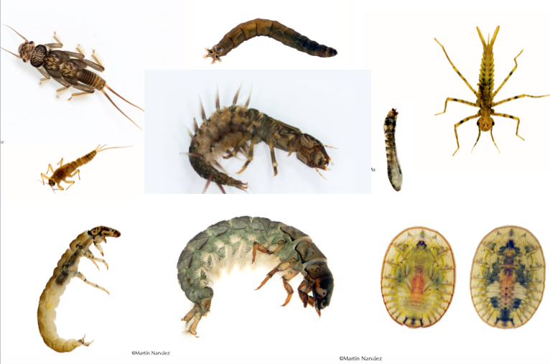
Examples of stream insects. From the top left, moving clockwise around the outside and spiraling into the center; stone fly, cranefly, damselfly, both sides of a water penny (a type of beetle), caddisfly, caddisfly, mayfly, dobsonfly, blackfly.
In 2013, massive flooding ripped through the Rocky Mountains in Colorado. Over the course of about 36 hours, nearly 25 inches of rain fell, with streams and rivers becoming raging torrents of milky brown water, studded with trees, cars, and houses. The size of the flood wasn’t the only unusual part of this disturbance, though. The rainstorm and flooding happened in September, months after snowmelt flooding usually happens in these rivers and streams in May or June.
I worked with a team of researchers from Colorado to understand how the insects that live in streams in the Rocky Mountains responded to these floods – did the unusual timing of the event take them by surprise? What characteristics did the lucky survivors have? Knowing what types of adaptations might help an insect survive an extreme flood like this could help us understand and predict how future stream insect communities might respond to the large floods predicted under many climate change scenarios.
But before I tell you what we found, why do we care about stream insects at all? Besides being fish food, stream insects are a majorly diverse and important part of the stream ecosystem. When leaves fall into streams in the fall, stream insects eat them and break them down, playing an important role in the carbon cycle. Many stream insects live in the water as juveniles and then have an adult stage that flies around in the air, like dragonflies do. These flying adults are an important food source for birds that live near streams. Stream insects are the unsung heroes of stream ecosystems and are the foundation of a healthy stream.
So did our stream insect communities do ok after the flooding in Colorado? Unsurprisingly, at many of our streams that were hit the hardest by the floods, we saw huge drops in stream insect diversity. At our most destroyed site, our stream insect community lost 10 species. However, some stream insects did better after the flood than before. One mayfly, in the Baetis genus, actually was more abundant in our streams after the floods than before. This mayfly is what we call a “weedy” species – one that is good at capitalizing on the opportunities that a disturbance provides to move in and reproduce quickly without other animals around to compete with it.
Prisoner Express 127 Anabel Taylor Hall Ithaca, NY 14850
One of our streams in Colorado after the floods. All those rocks and trees were moved by the floods. Before, trees and grass grew all along the banks of the stream, which now flows through a bed of gravel and boulders dragged along and dropped by the high flows.
We also wanted to know what characteristics of the insects, or what adaptations, determined whether the floods wiped them out or not. Overall, stream insects who were good at moving around the stream quickly in their larval juvenile stages and who had an adult phase where they could fly around outside of the stream did much better than stream insects who live their whole life cycle in the stream and have sluggish larvae that don’t move around well in the streams.
The flooding in Colorado also affected what food was available for stream insects to eat. Stream insects eat a range of foods, from algae and bacteria that grow on rocks in the stream and are really nutritious, to leaves that fall into the stream and are less nutritious. We found that after the flood, more leaves were available for the stream insects to eat, so stream insects were eating more of leaves. Rather than being picky eaters, the stream insects were being scrappy and were just eating more of the food that they could find more easily to survive after the floods.
Disturbances may still sometimes feel like an ecological mystery and a human nuisance, but we’re beginning to unravel their complicated effects and appreciate their importance. As an ambulance-chaser, I’m relieved when I get to a recently flooded stream and get to sit and watch a cloud of mayflies dance and fly their way out of the water’s surface. There’s something oddly hopeful about the tenacity and perseverance of these small creatures eking out a living after their home has been rearranged by floodwaters. As climate change threatens to make these floods more devastating and unpredictable, I hope the scrappiness of these amazingly diverse animals continues to win out against the forces of disturbance.

Ephemeral Wildflowers by Julia
Why do plants flower? The flower is the organ that plants use to reproduce and make seeds. Flowers have male and female parts that produce pollen and ovules (eggs), respectively. The flower protects the reproductive parts and helps pollination occur. Pollination is when the male pollen from a flower interacts with the female parts of a flower. The next step, fertilization, occurs when the pollen interacts with the ovule. This fertilized ovule then grows into a seed, which can be enclosed in a fruit.
Pollination can happen in different ways. Some flowers are self-pollinated, which means the pollen from a flower fertilizes the ovule from the same flower. But many flowers need to be cross-pollinated (pollen from a different flower pollinates the female parts) to create seeds. Cross-pollination can happen by wind, by water or by animals. Wind pollination relies on air currents to carry pollen from one flower to another. Grasses and trees (including pine trees) are often wind pollinated. Many water plants are pollinated by water, as water can easily carry pollen to other flowers. Flowers that are wind pollenated and water pollinated are often small. The most common pollination strategy is by animals. Animals that pollinate flowers include butterflies, moths, bees, wasps, flies, beetles, ants, hummingbirds, and even lizards and bats in some places! Most animals are attracted to flowers that have bright colors, good smells or energy-rich nectar. Different colors and shapes of flowers attract different types of animal pollinators. Hummingbirds are attracted to red flowers. Moths and bats are attracted to white flowers with strong scents that open in the evening. Bees are attracted to flat flowers that they can land on.
prisonerexpress.org prisonerexpress@gmail.com
Different plants flower in different ways and at different times in response to the environment and to their pollination strategy. I’ll discuss two types of flowering strategies and their pollinators – spring ephemeral flowers of the US East Coast and desert ephemerals of the US Southwest.
Many wildflowers of the East Coast grow in forests. This habitat has rich soils and adequate water but often has little sunlight. The dense canopies of the trees shade out the wildflowers on the forest floor, preventing them from absorbing sunlight and making sugars through photosynthesis. These forest plants grow and flower early in the spring, before the trees produce their leaves. These flowers are call spring ephemerals, as they grow quickly in the spring then die back during the summer when there is less sunlight hitting the forest floor. Most spring ephemerals are perennial plants, meaning they live for multiple years. A few spring ephemerals, such as false mermaidweed (Floerkea proserpinacoides) and fringed phacelia (Phacelia fimbriate), are annual plants which only live one year. The perennial wildflowers store energy in underground organs such as bulbs (such as trout lily, Erythronium species) so they can quickly grow in the spring. Some even have evergreen leaves (such as Hepatica species) that let them photosynthesize during the winter, after the trees have dropped their leaves. A few more examples of East Coast spring ephemerals are trilliums (Trillium species), bellworts (Uvularia species), Dutchman’s breeches (Dicentra cucullaria) and bloodroot (Sanguinaria canadensis). These flowers are pollinated by beetles, flies, bees, wasps, butterflies, and moths. Some pollinators are specialists, which means they only pollinate a few types of flowers. For example, the spring beauty mining bee (Andrena erigeniae) only pollinates spring beauties (Claytonia species), and the trout lily mining bee (Andrena erythronii) only pollinates trout lilies (Erythronium species)!

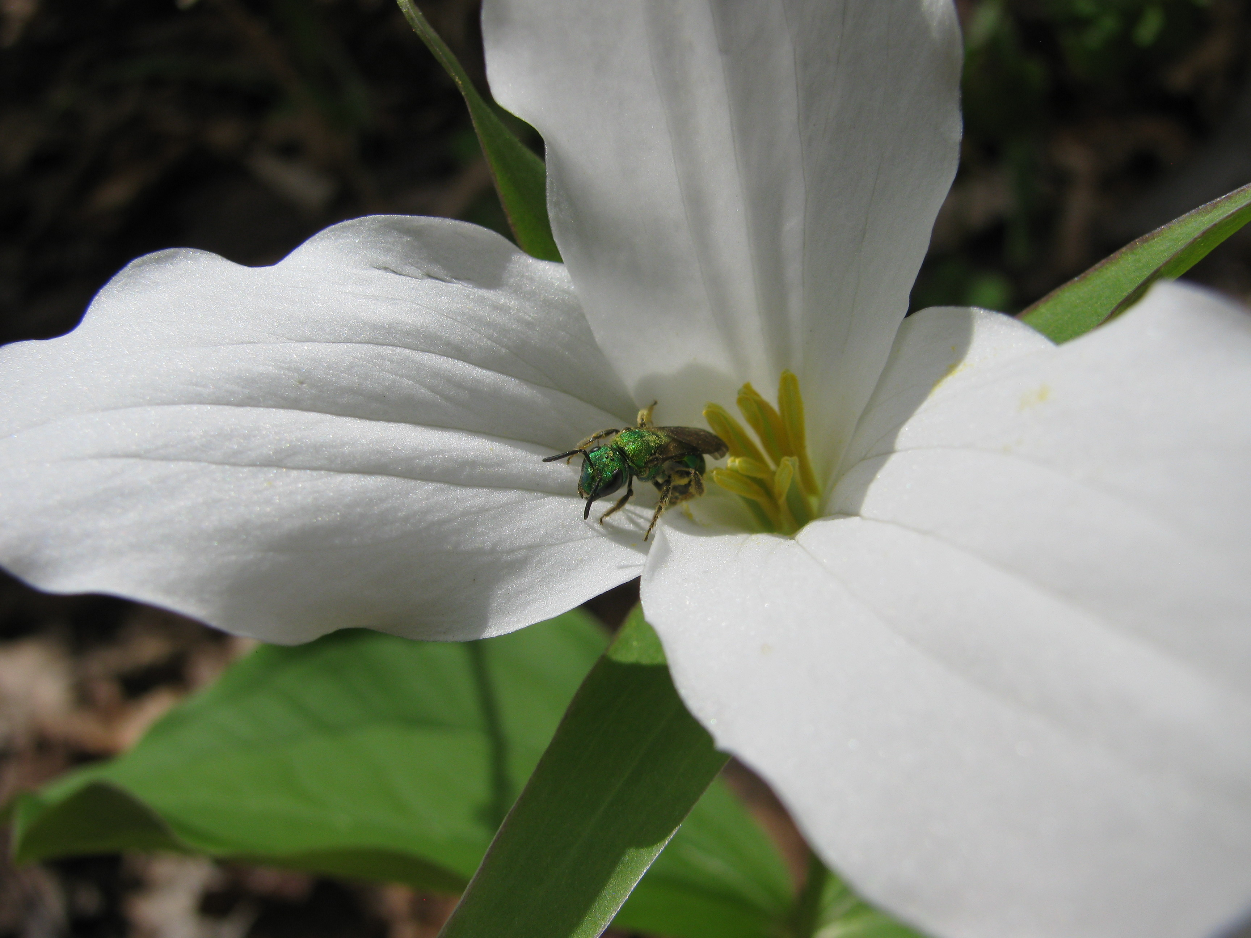
This large-flowered trillium (Trillium grandiflorum) has a nice landing platform for the pollinator, a sweat bee (Halictidae species).

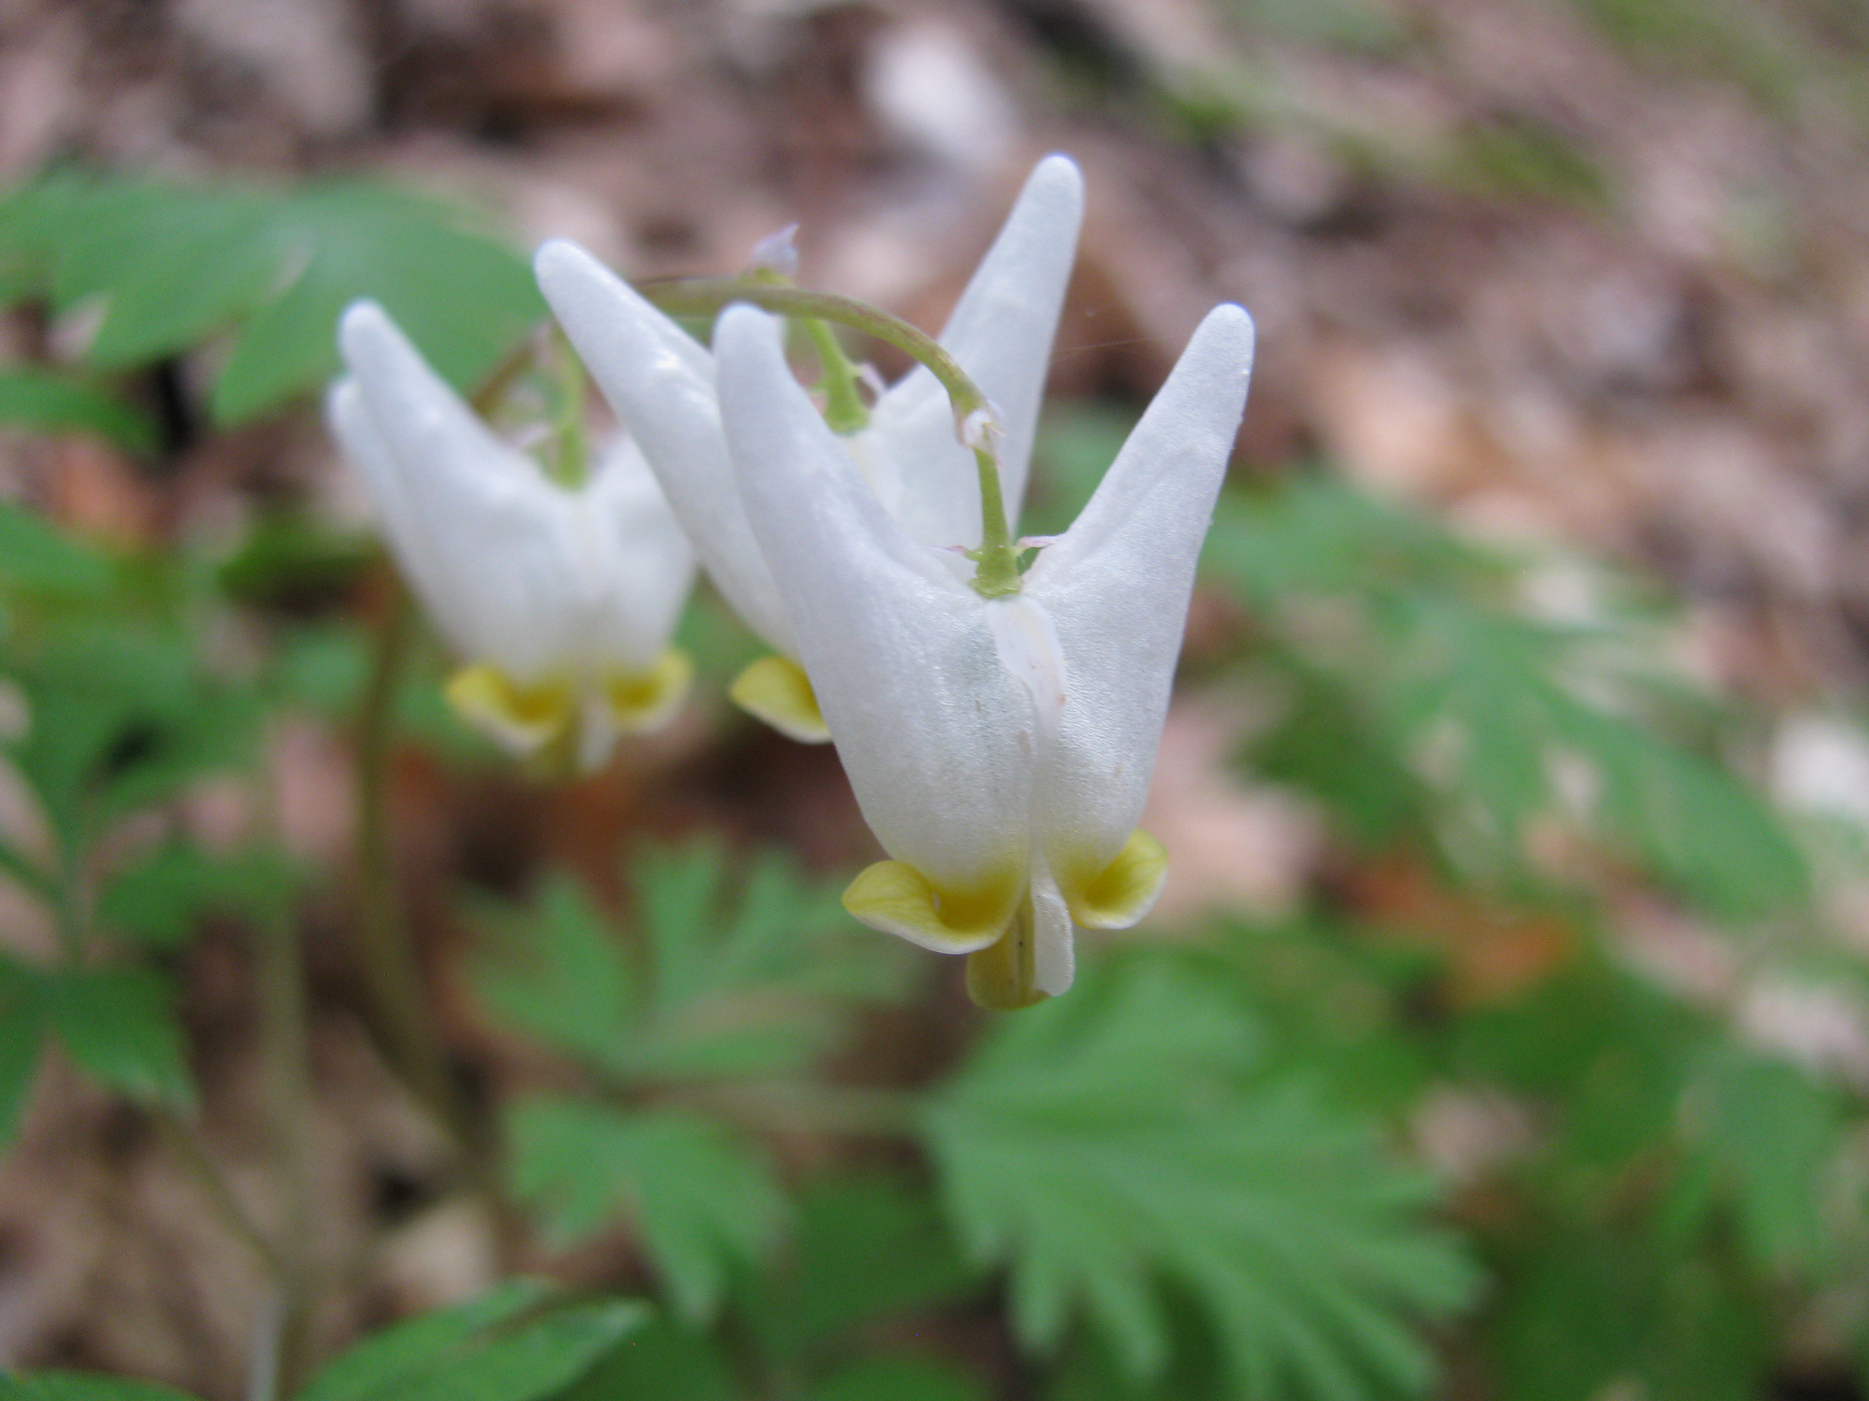
Dutchman’s breeches (Dicentra cucullaria) have very interesting flowers. Bumblebees (Bombus species) can force their way into the flowers to collect pollen.

Desert plants of the Southwest also face environmental hardships. However, desert plants don’t lack sunlight, they lack water! Desert plants have many adaptations to live in habitats that have little water. Some perennial plants store their water aboveground, like cacti. Cacti (Cactaceae family) have spikes to protect their water-filled stems. The surface of a cactus can be covered with white hairs (reflect sunlight) or waxy coating to prevent water loss. Other plants, such as the desert mariposa (Calochortus kennedyi) and the desert lily (Hesperocallis undulata), store water and energy in underground bulbs. Finally, there are desert ephemeral flowers that quickly sprout, grow and flower after a rain. They often flower all at once, covering the desert with flowers in events called ‘superblooms’. These desert ephemerals are annuals plants that grow from seeds that can survive for a long time in the soil, as there is no way to know when the next rain will be. Some examples include the Arizona poppy (Kallstroemia grandiflora), the Mojave lupine (Lupinus sparsiflorus) and the purple owl-clover (Castilleja exserta). These flowers are pollinated by a wide variety of pollinators, including beetles, flies, wasps, butterflies, moths, hummingbirds and bats. Some desert plants are also wind pollinated.

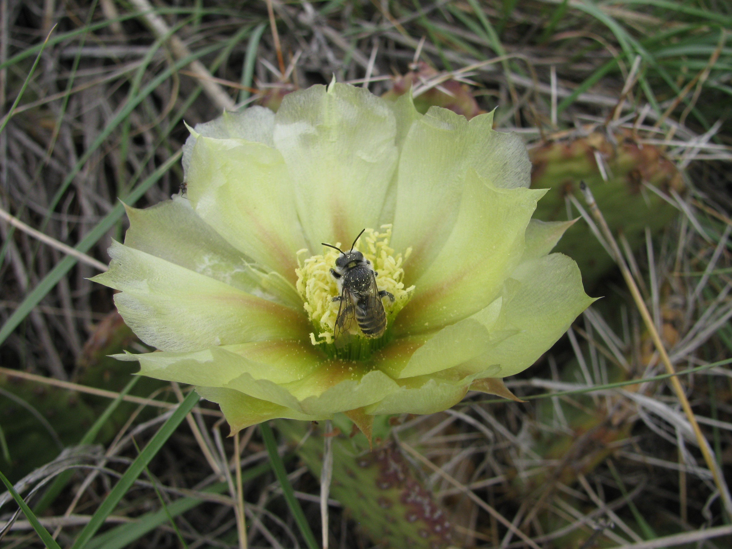
This is a plains prickly pear cactus (Opuntia polyacantha). There is a pollinator, most likely a type of bee, visiting the flower. Notice the spins on the cactus pads in the background.
Plants have evolved to produce flowers that attract different pollinators. They have also evolved strategies to flower at certain times when the environment is favorable. Flowers are beautiful examples of plants responding to their surroundings to successfully make seeds.

For the love of the game: how athletes sacrificing their bodies could also be sacrificing their brain function down the road by F. Korte
Last week, I got a concerned phone call from my mom. My brother had been hit pretty hard during his high school football game; she told me that when leaving the field, he couldn’t remember who he was, where he was, or what was going on.
She called me again the next morning to follow up. In spite of the hit and the serious symptoms he was exhibiting immediately after it happened, my brother had “passed” the concussion test protocol that was administered to him by the high school’s athletic trainer. She said she was no longer concerned, but I became even more concerned than I already was.
“Just because he may not have sustained a concussion doesn’t mean he didn’t sustain some serious head trauma,” I said. “We shouldn’t treat this lightly.”
“Well, he feels fine, the trainer says he’s fine, so there’s no reason for him to not go about his normal life. That includes playing in the next football game,” my mom replied. Surely, he must be okay, right?
Not according to me. As a New Englander, as a football fan, but most importantly, as someone interested scientifically curious about the human brain, my brother’s situation immediately brought my mind to Aaron Hernandez. As a former football star, Hernandez’s on-field performance for the New England Patriots earned him a $40 million contract in 2012. Earlier this year, he hanged himself in a prison cell while serving a life sentence for murder. He was only 27 years old.
Last week, around the same time that my brother took a blow to the head, neuropathologist Dr. Ann McKee from Boston University presented shocking findings from her post-mortem examination of Hernandez’s brain at a conference in Boston.
Prisoner Express 127 Anabel Taylor Hall Ithaca, NY 14850
prisonerexpress.org prisonerexpress@gmail.com
McKee has been studying chronic traumatic encephalopathy (CTE), a progressive degenerative disease which affects the brains of people who have suffered repeated concussions and traumatic brain injuries, for the past decade. She explained at the conference that, in total, she has examined about 468 brains affected by CTE. Of all of them, Hernandez’s brain was the worst: it showed the most damage her team of investigators had ever seen in an athlete so young. Post-mortem examination revealed that he had Stage 3 CTE; Stage 4 is the most severe. Only brains from humans at least 20 years Hernandez’s senior came close to his in terms of the degree of damage.
Interestingly, Hernandez’s brain appeared totally normal when the Boston University researchers first received it in April. It was not an unusual volume or size, not deformed or extraordinary in outward appearance – until it was sliced into half-inch sheaths from front to back. Then, even to the naked eye, McKee explains that you could see in the cross sections of the brain had hollowed out, with boomerang-shaped gaps where a normal, healthy 27-year-old brain would have been robust and fleshy.
His hippocampus and fornix, which play key roles in memory, had shrunken. The frontal lobe, which is responsible for problem solving, judgment, impulse control and social behavior was pockmarked with dark spots of tau protein, which is generally associated with Alzheimer brains. Tau protein essentially diseases and damages the brain cells essential for learning and memory. The amygdala, which regulates emotion, had been significantly affected, as had the temporal lobes that process sights and sounds.

Normal 27-year-old brain and Aaron Hernandez’s brain. Photo is courtesy of Boston University School of Medicine.
While as of now, Hernandez’s brain is considered to be a severe example of CTE, I think that his neuropathology speaks to a larger issue that is not limited to only professional athletes that play contact sports. Instead, it contributes to the already mounting evidence that CTE is ravaging the brains of young athletes, too. For example, a 2012 study by Dr. McKee’s team at Boston University found that long-term brain damage can still occur after playing only a few years of high school football.
Since researchers in the field can currently only diagnose CTE post-mortem, it is certainly difficult to determine whether the extent of this damage is because athletes are playing more aggressively, or if they’re starting at a younger age. Nevertheless, such evidence makes it clear that taking a hard hit isn’t just “part of the game.” It stays with players, leaving them with altered brain structure and function that near the state of Hernandez’s with each hit.
Both professional sport leagues like the NFL and high schools alike have attempted to make the contact sports safer via rule changes and policies designed to remove concussed players. However, it seems to be that even still, not enough caution is being taken to critically reassess how much of their bodies athletes at all levels are sacrificing “for the love of the game.”
The stigma needs to change. When it comes to protecting the brain, we – parents, coaches, players, at all levels – need to air on the side of caution. Because even if my brother’s high school athletic trainer says he doesn’t have a concussion, I believe that sacrificing his eligibility to play one game for the sake of proper rest and recovery is a lot easier to grin and bear than potentially sacrificing the functionality of his brain down the road.

Type A birds and shy spiders: the role of animal personalities in ecology and evolution by Young
Anyone who has interacted with cats or dogs knows that they have distinct personalities. Field biologists that spend a lot of time observing their study organisms in the wild have also been noticing such individuality between animals. Jane Goodall, a world-renown primatologist for her work on wild chimpanzees in the Gombe Stream National Park in Tanzania, was one of the first to publish her observations on the temperament of individual chimps. Subsequent tests in both the field and captivity confirmed that chimps had different yet consistent personalities, with females tending to be shy and having closely knit social groups. This phenomenon is not limited to our close relatives. At my current field site, we closely monitor a population of about 150-200 Florida scrub-jays, an avian species related to crows and blue jays. All our jays are banded with a unique combination of color bands for individual recognition, so we know that not all jays act the same. We have a wide spectrum of personalities ranging from jays that land on your head or beg by your feet like a puppy, to those that warily watch you from a perch or squawk at you incessantly.
In a biological sense, animal personality is defined as consistent, measurable behavioral differences among individuals that are maintained over time and across different contexts. Animal personalities have been reported in numerous vertebrates, from guppies to bighorn sheep, as well as some invertebrates such as spiders and water striders. Increasing number of studies have confirmed that not only do behavioral consistencies
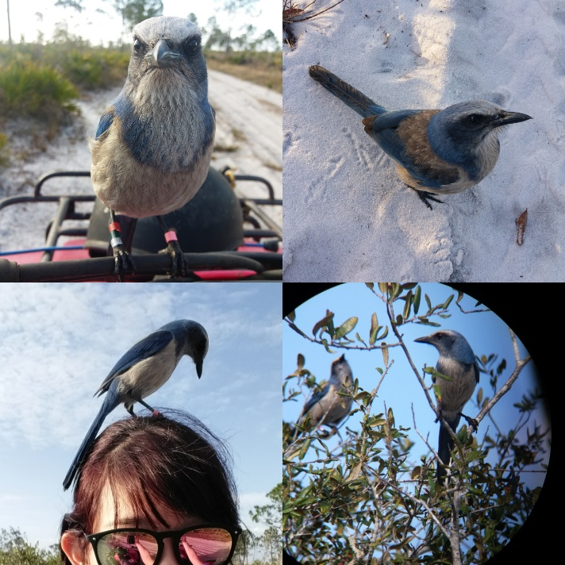
A few Florida scrub-jays from our study population. While most jays are observed from a distance using binoculars (bottom-right), we have a handful of individuals with “bold” personalities that readily approach the researchers. Individuals are marked and recognized with colored bands on their legs (seen in top-left).
among animals exist but also affect their survival and ecological impacts. For example, bolder animals may be able to outcompete their shyer counterparts and obtain more resources. However, such bold individuals may also take more risks that can expose them to predation.
Prisoner Express 127 Anabel Taylor Hall Ithaca, NY 14850
In the scientific field, however, long-standing thoughts against anthropomorphism – the act of attributing human characteristics, emotions, or intent to non-human animals – have prevented any formal investigation suggestive of animals having personalities. Back then, personalities were viewed as traits present only in humans and something frivolous in animals that was noted by zealous pet owners. Also, any individual variation within species was regarded as “noise” deviating from a trend and was discarded in data analysis and interpretation. Only within the past decade or two has the field of ecology and evolutionary biology started to acknowledge individual differences in behavioral tendencies. Even in animals that are conventionally considered as more primitive, like Trinidadian guppies or fire bugs, researchers could measure distinct personalities that were consistent over time and between individuals.
Animal personalities have various ecological implications that influence at both the individual and species level. On the individual level, certain personalities can benefit an animal’s survival and reproduction. In the Australian outback, male sleepy lizards that were less aggressive interacted more with females and fought less with other males than aggressive ones, suggesting distinct behavioral types that can improve mating success. Among Steller’s jays, a relative of the Florida scrub-jay, pairs that have similar behavioral tendencies of risk-taking were more successful at rearing young than dissimilar pairs. However, personalities can act as two sides of a coin. In fishing spiders, females with high voracious feeding tendencies also exhibited excess pre-copulatory sexual cannibalism (where females attack and eat a courting male) to the point where they killed all suitors and effectively sterilized themselves. If an animal’s personality can affect its survival and mating chances, then that animal is more likely to produce offspring that will carry on its genes and be more successful than other members of its kind.
Animal personalities have significant implications on the species level as well. In both Trinidadian killifish and great tits, bold individuals disperse farther from their birth origins to breed than their shy counterparts. In western bluebirds, highly aggressive males lead the invasion front, displacing their less aggressive sister species, the mountain bluebird. The coupling of a behavioral trait with dispersal has led to extensive range expansion of the western bluebird over the last 30 years in the northwest. Animal personalities have also been the basis for domestication of livestock and pets that started as early as 12,000 years ago. Humans have selected for more docile and tame personalities that could strive and breed in captivity, as seen in modern dogs or cattle. In the late 1950s, a Russian scientist experimentally achieved and expedited the domestication process by selectively breeding red foxes with tame personalities. After about dozen generations, the resulting domesticated foxes acted like dogs, being playful and friendly around people and responding to human cues like a dog would. These case studies strongly support how animal personalities have shaped a species existence and prosperity.
So why do animal personalities exist? This simple question can be approached in two ways by asking the proximate and ultimate causes of animal personalities. Proximate questions seek mechanistic explanations that include genetic, developmental, or physiological processes that shape an animal’s behavioral disposition. A fitting question would be, for example, what are the neurological basis of animal personalities? In rhesus macaques, aggressiveness is correlated to concentrations of serotonin, a neurotransmitter thought to be a contributor to feelings of happiness in humans, produced in the brain. Individual have different baselines of serotonin due to genetics or developmental processes, and this difference is behaviorally manifested through their degree of aggressiveness. In the case of domesticated animals, the selection of tameness is thought to be related to the reduction of neural crest cells, a type of vertebrate stem cell that appears in the embryo and develops into the development of other cells including brain tissues, pigments, and facial bone and cartilage structure. The reduction of certain brain tissue, particularly those that govern “fight-or-flight” responses to threats or novel stimuli, result in more tame animals which is what we would want in an animal that coexists with humans. The reduction of neural crest cells also explains why a lot of domestic animals have floppy ears, shorter snouts, and white or piebald pigmentation (imagine a dairy cow or border collie) – these traits are byproducts of selection for tameness.
Ultimate questions ask what the evolutionary drivers and ecological functions of animal personality are. For instance, what are the environmental factors that lead to the emergence of divergent personalities? Intensive research on great tits showed that environmental fluctuations selected for certain personalities between years. In particular, the synchronous production of mass seeds (“masting”) of beech trees was correlated with the selection on degree of exploratory behavior which was measured by how fast or slow a bird explores a novel environment. In poor winters without beech mast, competition intensified and fast-exploring individuals produced more young. Slow-exploring individuals did better in rich winters with beech mast and relaxed competition. Among the social tangle web spider, Anelosimus studiosus, females can be either docile or aggressive. Colonies consist of both behavioral morphs, or phenotypes, and their ratio drives the overall personality of the colony. Certain ratios have higher survival in some sites but not others. Temporal variation in environmental conditions favors different personalities that may explain why divergent personalities coexist within a species.
The study of animal personalities is an exciting new field that has only recently started to take off. It offers novel answers to long-standing mysteries in the field of ecology and evolutionary biology. Advancement in technology, such as microchips that record precise movement and molecular biology that provide insight on the genetics and biochemical reactions, have tremendously helped in pushing this field move forward. As more biologists note and quantify personalities in their study organisms, we will be able to learn more about how animals interact with the natural world and each other, each in their own unique ways.

Medication access isn’t enough; will your next donation actually fight AIDS? by Alexandra
I spent the morning on a folding chair in an outpatient HIV clinic in Hanoi, Vietnam, watching as a hundred patients filed through to pick up another month’s prescription of anti-HIV medication. They walked up, got their file stamped by the kindly Dr. Bao, spared a glance for the sweaty American in the corner, and received their pills without incident. In the seconds we had between patients, Dr. Bao explained that the clinic had gotten a lot busier over the last few years. In 2014, the Joint United Nations Commission on HIV and AIDS announced their strategy for ending the HIV epidemic, making access to anti-HIV medication an international priority. The statistics are promising; by 2016, 77% of those who knew their HIV status had access to treatment.
Unfortunately, accessing treatment is only helpful if the medication is working. As more and more people receive anti-HIV medication, the rate of viral resistance to these medications has also been rising. In 2017 11 countries collected viral resistance data. Shockingly, 6 of those countries reported that more than 1 in every 10 patients were unresponsive to that first round of treatment. It is essential that we prioritize drug resistance prevention alongside medication access in the fight against the HIV/AIDS epidemic.
Over time, the Human Immunodeficiency Virus (HIV) kills off the majority of an infected person’s immune cells. Eventually, their weakened immune system can no longer defend against infections that a functional immune system could fight off easily; and at this point patients are diagnosed with Acquired Immune Deficiency Syndrome, or AIDS. These opportunistic infections kill patients with untreated AIDS.
Dr. Bao’s patients were lined up for medication known as anti-retroviral therapy (ART). By preventing the virus from replicating in the body, ART decreases the amount of HIV circulating in an infected person’s bloodstream, limiting immune system damage. Effective ART is crucial to both prevention and treatment of the virus, as it dramatically reduces the risk of HIV transmission and can turn an AIDS diagnosis from a death sentence into a manageable chronic illness.
One woman had come to the clinic get the results of her last viral load test, a blood test that would reveal the extent to which HIV was replicating in her body. There was nearly 50x more HIV in her bloodstream than there should have been, given that she had been prescribed ART when she tested positive for HIV 8 months ago. Dr. Bao discovered her medication made her nauseous, so she had stopped taking it on days when she had to work. She felt healthy and didn’t understand why missing a dose or two was a problem.
Due to the rapid expansion of access to ART, overburdened clinical staff don’t always have time to teach patients how to take their medication when it’s first prescribed. Unpleasant side effects, stigma, and simply forgetting to add ART to your schedule often play a role in sub-optimal adherence and patients like this woman just don’t understand what’s at stake if their adherence starts to slip.
ART must be taken at the same time every day, to keep the drug concentration high enough to suppress viral replication, but not high enough to be toxic. Irregular administration of ART (missing 5%- 10% of daily doses) causes the drug concentration in their bloodstream to drop between doses and allows the virus to replicate. HIV changes slightly each time it replicates so that each viral copy is different from the last. Every now and then, one of these mutations modifies the virus such that a specific anti-retroviral drug is no longer effective against it. When the patient resumes taking their ART, this resistant version of the virus will continue to proliferate. Patients with viral resistance risk developing AIDS and/or passing the resistant virus to others.
Poor adherence isn’t just a problem in Vietnam; on average, a staggering 41% of North American patients skip at least 1 out of every 10 ART doses according to a 2011 study. That is 41% of patients risking developing AIDS and/or transmitting resistant virus. Additionally, the ease of international travel means that resistant HIV is not confined to the region in which it developed.
Viral resistance is a global issue, but it doesn’t have to be. Treatment is becoming increasingly available and works when taken correctly.
As organizations across the world fund the scale up of ART access, they need to ensure that new patients understand what optimal adherence looks like and why it matters. There is ongoing research into apps, pillboxes, and other strategies to help patients improve their adherence, hopefully before viral resistance develops. These strategies are important, but HIV+ people should have enough information to make informed decisions about how they take their ART in the first place. Effective anti-HIV campaigns need to pair increased medication access with corresponding funds for patient education, giving clinics the resources to prepare an influx of new patients for successful ART.
Prisoner Express 127 Anabel Taylor Hall Ithaca, NY 14850
The next time you donate to the fight against the AIDS epidemic, take a minute to read over the strategy of the organization you’re considering. You can help to protect yourself, your community, and the world from resistant HIV by choosing an organization that prioritizes medication adherence and patient education, not just access.

A venomous creature from the deep by Allison
A monster lurks below the surface in paradise. Its face is covered with streaks of bright colors and its threatening spines are packed with venom. It moves slowly because it can, waiting for unsuspecting prey to wander too close.
Although this may seem like a scene from a horror movie, it is in fact the very real life of the lionfish. Given its bright colors and startling appearance, it’s not surprising that it has earned other, more threatening names. It is also known as the devil firefish or the scorpion cod.
Lionfish are native to the crystalline, coral-studded waters of the Indo-Pacific where their spines strike fear in tourists on the reefs around Japan, Australia, and the Pacific islands. But they’re the locals around these parts and, ecologically, they belong there. The problem is that the Indo-Pacific can no longer contain them. They are showing up in new and unexpected places.
The expansion of species far out of their native range is not uncommon in the present era of globalization. We are moving ourselves and other organisms all around the globe through worldwide travel and shipping. In fact, there is an ominous name for organisms that have broken out of the bounds of their native range: invasive species. Well-known invasive species in the U.S. include the jumping Asian carp in the Great Lakes, Burmese pythons roaming the Florida Everglades, and the kudzu vine that is slowly but surely overgrowing the forests of the southeast. As the name suggests, invasive species aren’t showing up to play nice.
Lionfish are invasive in the Caribbean where they threaten native ecosystems by gobbling up colorful reef fish. The decline in reef fish would itself be tragic and worrisome, but there is also a domino effect from this fish mortality. Reef fish serve as important herbivores on reefs, grazing algae off the surface of corals like benevolent cows. Without the clean-up services from these fish, corals can become overgrown with algae and die. The corals are the foundation for the coral reef and when they die, they take everything with them.
But like many monsters of literary and cinematic fame, lionfish are a bit misunderstood. First of all, they were not holding covert meetings in the Indo-Pacific, planning an invasion of the Caribbean. They’re fish. Instead, they were spread by humans who brought the colorful lionfish from the Indo-Pacific to sell in the aquarium trade. Over time, they occasionally escaped into the natural environment or were released by owners who no longer wanted a pet fish. Secondly, the treacherous spines adorning their backs are not for luring in tourists and sending them on trips to the emergency room. They are there for defensive purposes to deter predators that might eat the lionfish. After all, it’s fight or flight, and lionfish can’t swim away quickly so they choose to fight.
All this talk of predators might bring to mind a pretty simple solution: why don’t bigger predators just eat the lionfish in the Caribbean so they would not have such a detrimental effect on reef fish? Unfortunately, it’s not that simple. There are no natural predators of lionfish among the fish and other animals that inhabit the Caribbean. It’s not hard to imagine why: it takes a very adept predator to deal with all those spines!
Luckily, humans are some of the most adept organisms out there. Recognizing this opportunity, several organizations are trying to teach the public how to eat lionfish, venomous spines and all. The delicate process involves puncture-proof gloves, tongs and kitchen shears. These fish can be dangerous even when they’re dead!
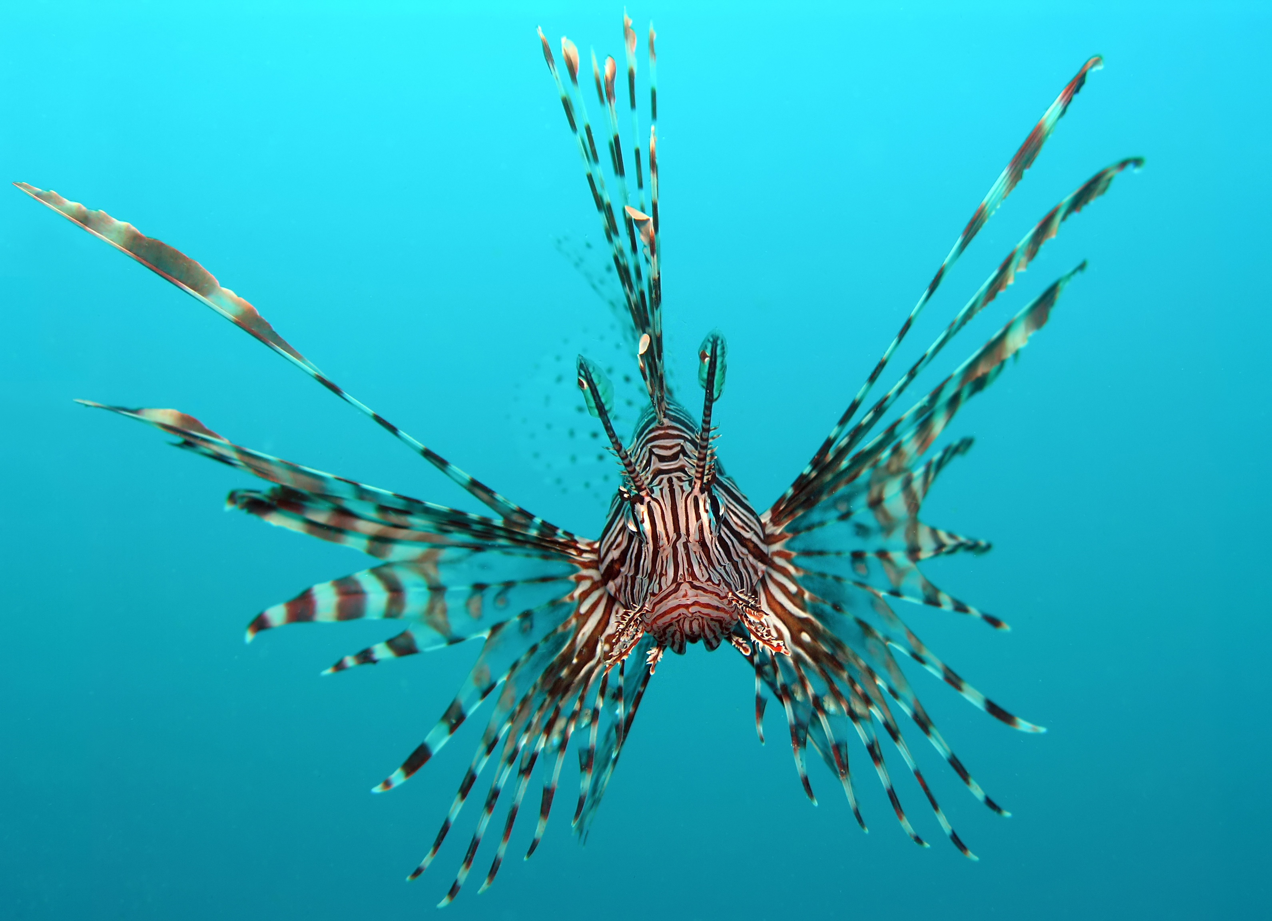
In “Sustainable seafood: A solution to end overfishing?” (the next article), Kristina notes that eating invasive species like lionfish can help the overfishing crisis. Lionfish hold promise as a source of sustainable seafood in the Caribbean, a region that has been chronically overfished. The benefits are twofold because, by eating lionfish, we become the predators that lionfish lack in the Caribbean. Not only do we get a delicious meal, but serving up lionfish for dinner could help more reef fish live to graze another day, ultimately helping coral reefs survive.
If cookbooks and restaurants succeed in making them popular enough, human consumption could help fight this venomous threat to coral reefs. All we have to do is sit and wait for unsuspecting lionfish to wander too close.
Lionfish, photo from J. Petersen

Sustainable Seafood: A Solution to End Overfishing? By Kristina
I love sushi. In fact, it is one of my favorite cuisines. My favorite types of raw fish are salmon and red snapper, while I find tuna bland. It appears, however, that the majority of sushi consumers disagree with me, as Bluefin tuna is one of the most popular types of fish used in this Japanese cuisine and is almost guaranteed to be on the menu at most sushi joints. While this may be good news for sushi lovers, the tuna definitely get the shorter end of the chopstick.
Pacific Bluefin tuna populations have declined dramatically due to overfishing. Prior to World War I, Bluefins were rarely caught; the end of the war and production of better fishing equipment commenced the tuna fishing craze that is prevalent today. As of 2016, the population dropped by 97.4 percent, putting the current Bluefin tuna population at just a mere 2.6 percent of what it was prior to 1910. The major culprit behind this decrease is the high demand for its use for sushi. Within the seafood industry, around 80 percent of all Bluefin tuna used for sushi consumption. Adding to this realization, projections suggest that the Bluefin tuna has less than a one percent chance of rebuilding their population to healthy levels within the next two decades. Unless we want to add the Pacific Bluefin tuna to the list of endangered species, fisheries and consumers need to take action.
How can we stop overfishing Bluefin tuna? Is the solution to simply stop indulging in spicy tuna rolls or tuna maki? The problem of overfishing is not only caused by the consumers, but also the fishermen and environmental scientists. While consumers ultimately have control due to their market power, all involved parties are responsible for putting an end to overfishing.
Studies have convinced me that an end to overfishing is possible, without decreasing overall fisheries’ production. Researchers suggest shifting the focus away from highly targeted species towards underutilized or even invasive species in an attempt to reduce pressure on overfished species, like the Bluefin tuna. While redistributing fishing pressure may seem like a small effort, it can have major impacts. When any species in particular is targeted due to high demands, a shift occurs in the structure and function of the marine ecosystem, disrupting the food web and marine life. In order to preserve the integrity of marine ecosystems, “balanced harvesting” offers the solution.
Currently, the high trophic level species tend to be the most overfished, mainly due to its economic value. However, in order to fully obtain balanced harvesting, researchers acknowledge that some sort of value must be added to low trophic level species. Low trophic level species refers to an organism that resides within the lower positions on a food chain. By fishing down the food web, it is possible to add value to these less desirable fish. In an attempt to alleviate the pressure from selective overfishing through increasing consumer interest in low trophic level seafood, it is possible to make fisheries more sustainable. A few examples of low trophic level seafood include: herring, sardines, anchovies, shellfish, shrimp, and other forage fish.
The Monterey Bay Aquarium provides consumer guides that allow individuals to make sustainable seafood choices; there are many low trophic level and invasive species that are deemed some of the “best choices” on the seafood watch guide. The guide also varies by location, allowing consumers to make sustainable seafood choices wherever they may live or travel. Sustainability is not a new concept. The United Nations World Commission on Environment and Development first introduced the idea of sustainable development in Our Common Future in 1987. So, what does sustainability truly mean? In terms of seafood, environmental sustainability refers to stewarding resources in a conservative manner, so they remain viable and available in the future.
If this is the definition of sustainable we chose to adopt, then how can there be such a thing as sustainable sushi? Restaurants utilizing invasive species for culinary use are currently on the rise. The sushi that is made consciously from invasive species is appropriately coined sustainable sushi because it helps with the overall goal of balanced harvesting, thus allowing fisheries to become more environmentally sustainable. A leader in sustainable development in Connecticut, Miya’s is the world’s first sustainable sushi restaurant. Miya’s has gained a strong following, suggesting that expanding sustainable sushi and replacing old over-fished favorites for a new dish on the invasive species menu is a real possibility.
Prisoner Express 127 Anabel Taylor Hall Ithaca, NY 14850
Lionfish is another invasive species that has landed a spot on the menu of many seafood restaurants in the Caribbean and Florida. Lionfish populations are currently jeopardizing the marine ecosystem in the Caribbean, Gulf of Mexico, and off the coast of Florida. They are a top predator in reef communities and are outcompeting native species. If you are interested in trying lionfish and love to cook, the Reef Environmental Education Foundation (REEF) published a lionfish cookbook filled with recipes for a home-cooked sustainable seafood meal. If cooking is not for you, then you can still try this invasive species at these restaurants serving lionfish on their menus.
The goal is not to drive people away from their favorite seafood restaurants and sushi bars, but rather to educate consumers to make better-informed decisions. If you’re in the mood for a home-cooked meal, check out the sustainable recipes from Seafood Watch. Or, if you prefer a dine-in experience review the sushi guide and try ordering Arctic char instead of tuna. Not only will your environmentally conscious decision to order a low trophic level fish help combat overfishing of popular fish, but you may also find a new favorite that you can feel good about eating!

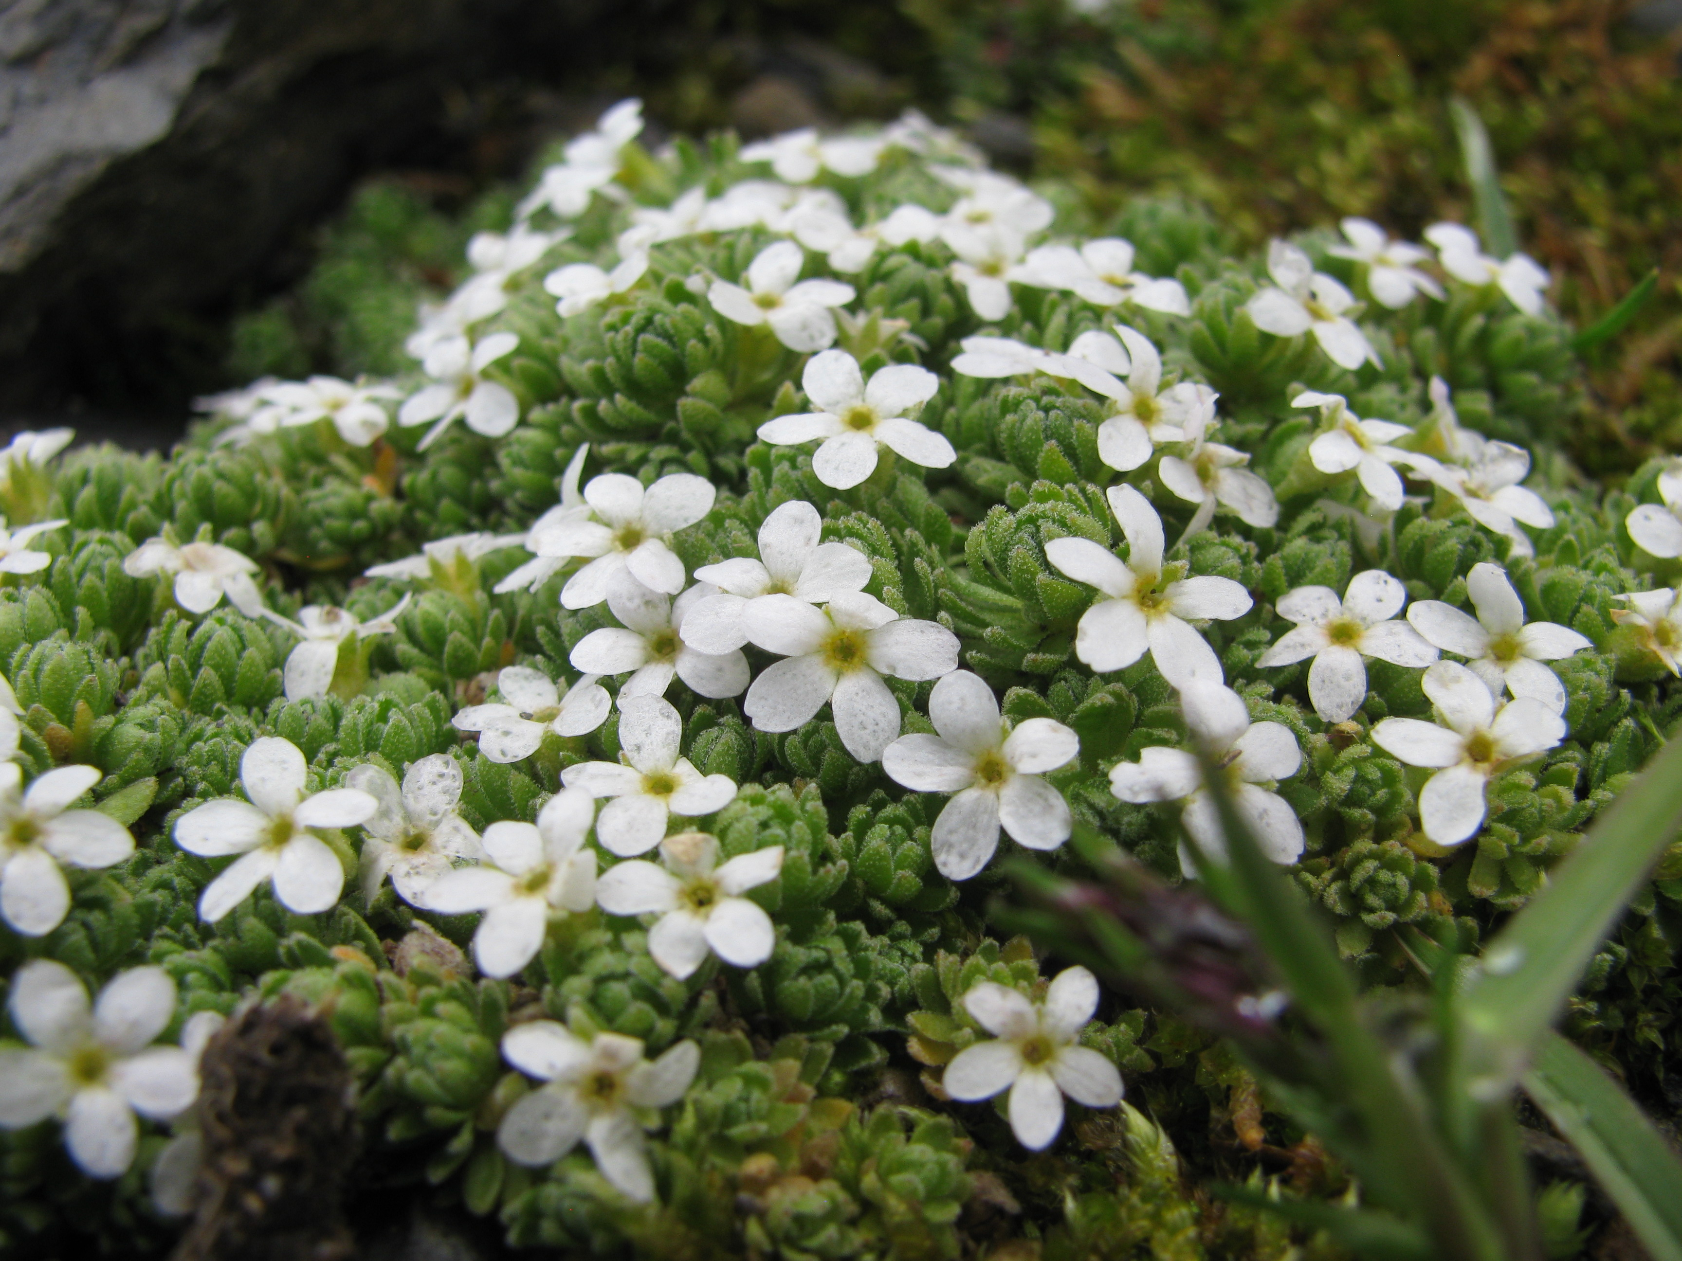
Photo from Julia of Swiss rock-jasmine, Androsace Helvetica, which is found in the Alps, the Dolomites and the Pyrenees above 5,000 feet. They grow in a clump to protect themselves from the dry and harsh winds of the mountains. Read Julia’s article about wildflowers inside!

Non-Profit Organization
US Postage Paid
Permit 448
Ithaca, NY 14850
CTA/Durland Alternatives Library
127 Anabel Taylor Hall
Ithaca, NY 14853
www.prisonerexpress.org

